UNIT 1 – PROGRAMMING
Zid’Avwa Al Bari’i
244107020083 – TI 2I - 26

Exercise 1
- Example of a constant in the code is 3
- Value of x after the third instruction 3

Exercise 2
(Number the variables in the order they’re explained)
Order: g_Move g_Turn key_Press

Fill the blanks:
1. If g_Move has the value 0, the robot does not move.
2. If g_Turn has the value 0, the robot goes straight.
3. If you press ‘x’ on the phone, key_Press has the value x.

Exercise 3
(Label directions with phone keys — typical WASD or arrows logic)

- ↑ = w (forward)
- ↓ = s (backward)
- ← = a (left)
- → = d (right)

Exercise 4 (Match terms with definitions)
- flowchart : E
- source code : A
- compiler : G
- machine code : H
- debugging : C
- assembly language : F
- high-level language : D
- markup language : B

Exercise 6 (Put steps in correct order)
- C. Understand the problem and plan a solution
- D. Take a flowchart of the program
- A. Write instructions in a programming language
- E. Compile the program (to turn it into machine code)
- F. Test and debug the program
- B. Prepare documentation

Exercise 7 (Fill in the blanks)
Steps in Programming
- program
- flowchart
- language
- compiled
- errors
- debugging
- documentation

Exercise 9 (Flowchart symbols)
- Terminal (Start/Stop) - Indicates beginning/end of a program.
- Input/Output - Shows data input or output.
- Process - Represents actions or operations.
- Decision - Represents branching based on condition (yes/no).
- Arrow - Shows direction of flow.
- Connector - Connects parts of flowchart.
- Predefined Process - Represents a subroutine.

Exercise 10 (True/False corrections)
- T
- F → Correction: It is possible to draw a flowchart freehand without a template.
- F → Correction: There can be different flowcharts for the same problem.
- T
- F → Correction: The method of flowcharting does not depend on the programming language.
- T
- T
- F → Correction: Even if a flowchart is correct, the program may still not work if coding has errors.
- T
- F → Correction: Flowcharts can show both processes and decisions.

Exercise 11 (David’s flowchart sequence)
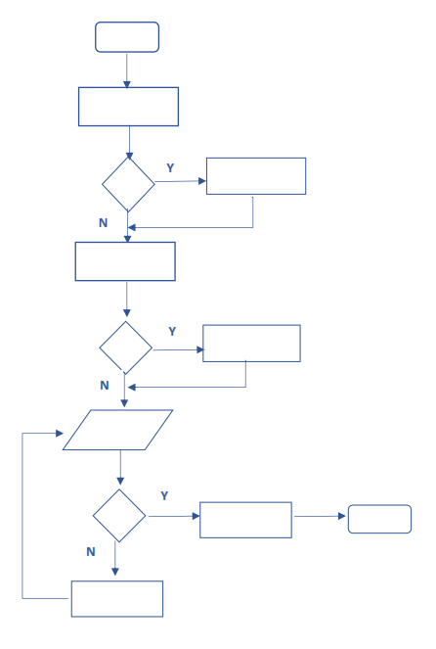
E
F
G
J
D
A
L
H
B
I
C
K
k. Start
c. Get up, wash, and dress
e. Newspaper delivered?
Yes : b. Take in and put newspaper in the living room i. Have breakfast
No : i. Have breakfast
h. Any homework?
Yes : j. Complete homework
No : d. Check time
g. Time to go?
Yes : f. Go to the campus
No : a. Read newspaper back to check time
l. Stop

Exercise 12
Flowchart: Withdraw Money from ATM
- Start
- Insert ATM card
- Enter PIN
- If PIN correct → continue
- If PIN incorrect → re-enter or card blocked
- Choose “Withdraw” option
- Enter amount of money
- If balance sufficient → continue
- If balance insufficient → display error
- ATM dispenses cash
- Take receipt (optional)
- Collect card
- End
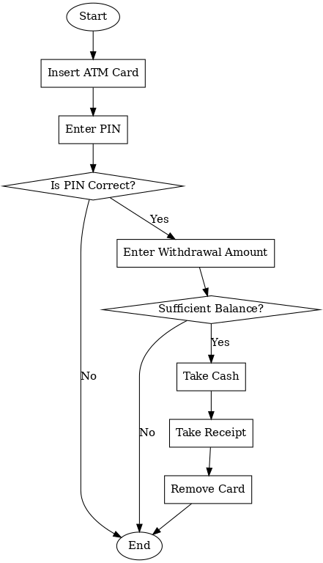

Exercise 13
This flowchart describes the process of buying something from a vending machine. First, the user inserts money and selects an item. If the item is available, the vending machine dispenses it and the user collects it. If not, the machine displays 'Out of stock' and refunds the money. The process ends afterwards.

Exercise 14 (Word search – 10 programming words)
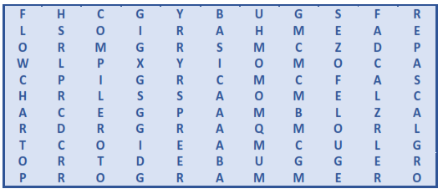
- BUGS
- DEBUGGER
- PROGRAMMER
- FLOWCHART
- COMPILER
- JAVA
- HTML
- SQL
- OBJECT
- SYSTEM

Exercise 15 (Computer Languages – Q&A)
- No, computers do not understand human languages, they only understand machine code.
- An assembler translates assembly language into machine code.
- Seven: FORTRAN, COBOL, BASIC, PASCAL, C, C++, Java.
- High-level languages make programming easier and solve intercommunication problems.
- Compiler translates the whole program at once, interpreter translates line by line.
- Because they use markup tags to structure and link content.

Exercise 16 (Complete the sentences)
- XML
- FORTRAN
- Java
- VoiceXML
- COBOL

Exercise 17 (Reported screen messages)
- It tells you to make sure the printer is switched on before continuing.
- It informs you that game mode is on.
- It asks you if you want to create a new document.
- It asks you what the captcha code is.
- It asks you to fill in your name in the box.
- It tells you to type the next number.
- It asks you to enter your password.
- It tells you to choose from the menu below.
- It informs you that you can’t rename 'Pictures' because a folder with that name already exists.
- It asks you if you want to exit.
- It asks you if you are sure you want to copy the selected files.
- It asks you if you want to defrag the drive.
- It asks you if you want to mute story and posts.
- It informs you that if you unfollow this account, you’ll have to request to follow again.
- It tells you to click the subscribe button to follow.

